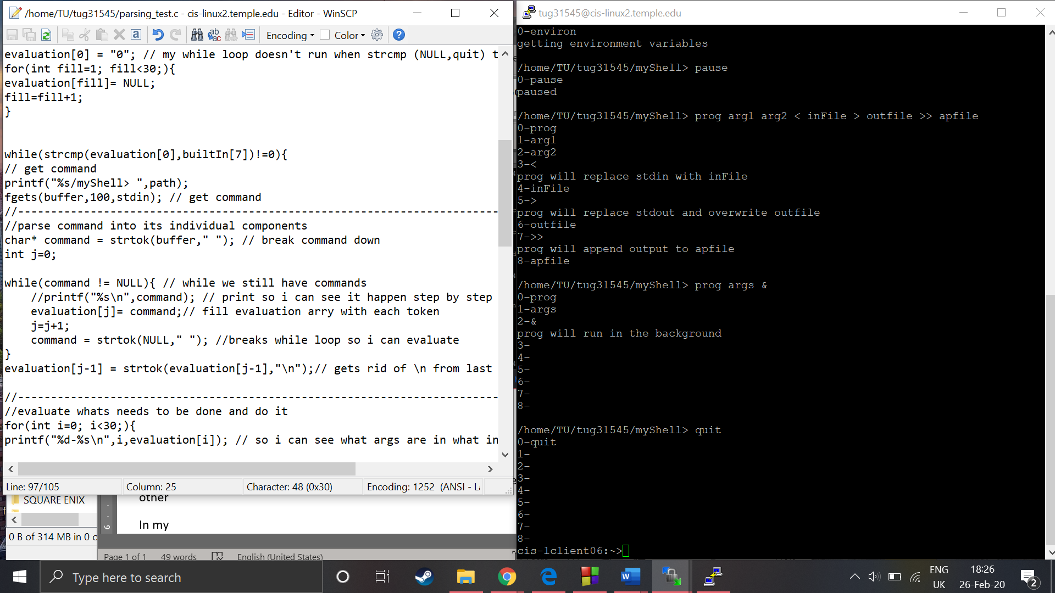Parsing Test: As of(25/02)

This show that my parser is mostly working. I need to figure out how

- I’ll now identify how many args follow the program call.

- Replace my print statements with function calls and test again to see how my units interact with each other

-In my last 2 calls my evaluation buffer still seems to have black values in it. They don’t seem to interfere with the parser at the moment but this could potentially become a problem